# CL118

**Programming Fundamentals**

# Lab 01

Pre-Programming phase



FAST – National University of Computer & Emerging Sciences Karachi, Pakistan

**LAB 01**

**Learning Objectives**

This lab will cover the following topics:

* Problem Solving Concepts for the Computer
* Pre-Programming Phase
* Introduction to flow chart

## Problem Solving Process General Problem Solving Method

1. Define and understand problem
2. Sketch the problem
3. Gather information
4. Generate and evaluate potential solutions
   1. Use applicable theories and assumptions
5. Refine and implement solution
6. Verify and test solution

## What Problem Can Be Solved By Computer

* When the solution can be produced by a set of step-by-step procedures or actions.
* This step-by-step action is called an algorithm.
* The algorithm will process some inputs and produced output.
* Solving problem by computer undergo two phases:

#### Phase 1:

* + - Organizing the problem or pre-programming phase.

#### Phase 2:

* + - Programming phase.

## PRE-PROGRAMMING PHASE

This phase requires five steps:

1. Analyzing the problem.
2. Developing the Hierarchy Input Process Output (HIPO) chart or Interactivity Chart (IC).
3. Developing the Input-Process-Output (IPO) Chart.
4. Drawing the Program flowcharts.
5. Writing the algorithms

### Analyzing The Problem

* + - Understand and analyze the problem to determine whether it can be solved by a computer.
    - Analyze the requirements of the problem.
    - Identify the following:
      * Data requirement.
      * Processing requirement or procedures that will be needed to solve the problem.
      * The output.
    - All These requirements can be presented in a Problem Analysis Chart (PAC)

|  |  |  |
| --- | --- | --- |
| **Data** | **Processing** | **Output** |
| Given in the problem or provided by the user. | List of processing required or procedures. | Output requirement. |

#### Example # 01:

Write a Problem Analysis Chart (PAC) to find an area of a circle where

## area = pi * radius * radius

|  |  |  |
| --- | --- | --- |
| **Data** | **Processing** | **Output** |
| radius | area = 3.14 x radius x radius | area |

### Developing the Hierarchy Input Process Output (HIPO) or Interactivity Chart

* The problem is normally big and complex.
* Thus, requires big program.
* Thus, the processing can be divided into subtasks called modules.
* Each module accomplishes one function.
* These modules are connected to each other to show the interaction of processing between the modules.
* Main/control module controls the flow all other modules.
* The IC is developed using top-down-method: top to down left to right order (also refer to order of processing).
* Modules are numbered, marked for duplication, repetition or decision.

The interaction will form a hierarchy, called Hierarchy Input Process Output Chart (HIPO) or Interactivity Chart (IC). Programming which use this approach (problem is divided into subtasks) is called ***Structured Programming***.

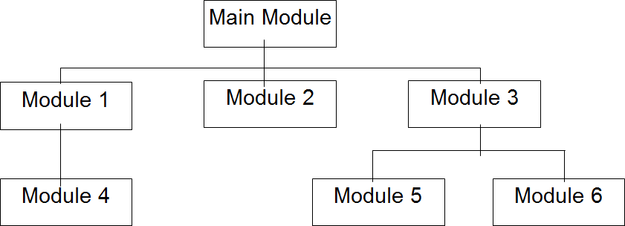

#### Example # 02:

Write a Hierarchy Input Process Output (HIPO) to find an area of a circle where

### area = pi * radius * radius

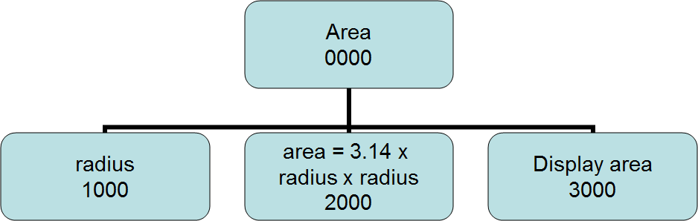

* 1. **Developing the Input Process Output (IPO) Chart**
     + Extends and organizes the information in the Problem Analysis Chart.
     + It shows in more detail what data items are inputs, what is the processing or modules on that data, and what will be the result or output.
     + It combines information from PAC and HIPO Chart.

#### Example # 03:

Write a Input Process Output (IPO) to find an area of a circle where

### area = pi * radius * radius

|  |  |  |  |
| --- | --- | --- | --- |
| **Data** | **Processing** | **Module** | **Output** |
| - radius | * Enter radius * area = 3.14 x radius x radius * Display area * end | 1000  2000  3000  0000 | - Area of a circle |

* 1. **Drawing the Program Flowcharts**
     + Flowchart is the graphic representations of the individual steps or actions to implement a particular module.
     + The flowchart can be likened to the blueprint of a building. An architect draws a blueprint before beginning construction on a building, so the programmer draws a flowchart before writing a program.
     + Flowchart is independent of any programming language.
     + Flowchart is the logical design of a program.
     + It is the basis from which the actual program code is developed.
     + Flowchart serves as documentation for computer program.
     + The flowchart must be drawn according to definite rules and utilizes standard symbols adopted internationally.

The International Organization for Standardization (IOS) was the symbols shown below (You can draw the symbols using ready-made flowcharting template):

**Flowchart** is a diagrammatic representation of sequence of logical steps of a program. Flowcharts use simple geometric shapes to depict processes and arrows to show relationships and process/data flow.

#### Flowchart Symbols

Here is a chart for some of the common symbols used in drawing flowcharts.

|  |  |  |
| --- | --- | --- |
| **Symbol** | **Symbol Name** | **Purpose** |
| Start Stop | Start/Stop | Used at the beginning and end of the algorithm to show start and end of the program. |
| Process | Process | Indicates processes like mathematical operations. |
| Input/ Output | Input/ Output | Used for denoting program inputs and outputs. |

|  |  |  |
| --- | --- | --- |
| Decision | Decision | Stands for decision statements in a program, where answer is usually Yes or No. |
| Arrow | Arrow | Shows relationships between different shapes. |
| On-page Connector | On-page Connector | Connects two or more parts of a flowchart, which are on the same page. |
| Off-page Connector | Off-page Connector | Connects two parts of a flowchart which are spread over different pages. |

#### Guidelines for Developing Flowcharts

These are some points to keep in mind while developing a flowchart −

* Flowchart can have only one start and one stop symbol
* On-page connectors are referenced using numbers
* Off-page connectors are referenced using alphabets
* General flow of processes is top to bottom or left to right
* Arrows should not cross each other

**Example Flowcharts**

Here is the flowchart for going to the market to purchase a pen.

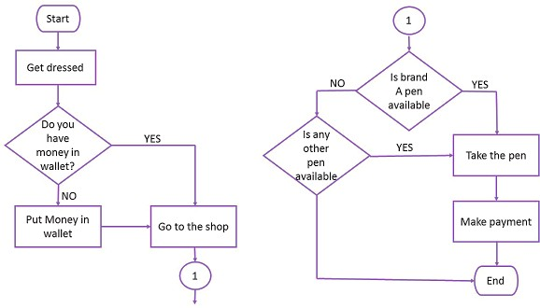

Draw a flowchart to calculate the average of two numbers.

## LAB TASK

**Question # 01:** Write a Problem Analysis Chart (PAC) to calculate the gross pay of an employee given the hours worked and the rate of pay.

**Question # 02:** The summer surveying job requires an employee to study some maps that give distances in kilometers and some that use miles. He with his co-workers prefer to deal in metric measurements. Draw an IPO chart to calculate the distance in kilometers. where 1.609 kilometers per mile.

**Question # 03:** When Ali began his trip from Karachi to Gilgit, he filled his car’s tank with gas and reset its trip meter to zero. After travelling 324 miles, Ali stopped at a gas station to refuel; the gas tank required 17 gallons. Create a IPO chart to display the car’s gas mileage (the number of miles his car can be driven per gallon of gas).

**Question # 04:** Draw a flowchart for a problem that to read two numbers. The first number represents the unit price of a product and the second number represents the quantity of the product sold. Calculate and print the total sale.